First Challenge — Complete DevOps Setup on a Single EC2 Instance
Objective
Launch one EC2 instance using Amazon Linux 2 and install, configure, and run all the required DevOps tools and web servers on that same EC2 instance.
Requirements
- Launch one EC2 instance
  - AMI: Amazon Linux 2
  - Instance type: t3.small
- Install and configure Docker
- Install and configure Jenkins
- Install and configure Apache HTTP Server
- Install and configure Nginx
- Install and configure Apache Tomcat
- Ensure all services are running simultaneously on the same EC2 instance
- Configure different ports where necessary to avoid port conflicts
Port conflict
Jenkins normally uses 8080, while Tomcat can use 8082. Apache and Nginx need different ports because they cannot both use port 80.
We'll configure:
- Apache → 80
- Jenkins → 8080
- Nginx → 8081
- Tomcat → 8082
This allows all services to run simultaneously on the same EC2 instance.
Launch EC2
- Launch one EC2 instance
- AMI: Amazon Linux 2
- Instance type: t3.small
- Create/select a key pair
- Configure Security Group
- Launch instance
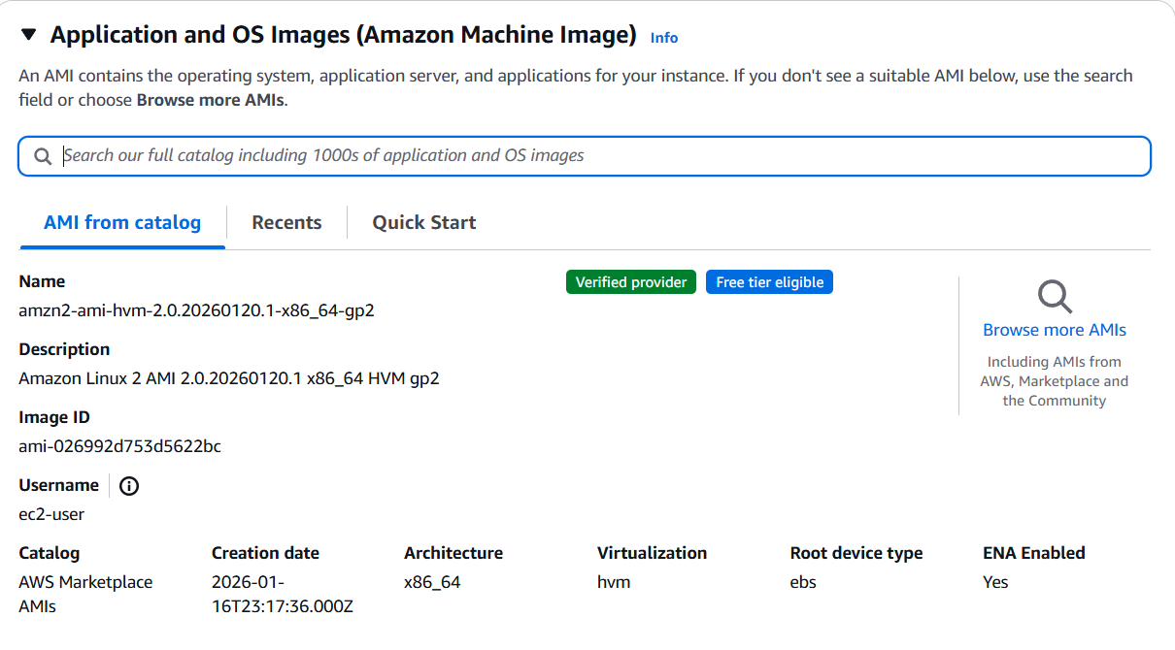
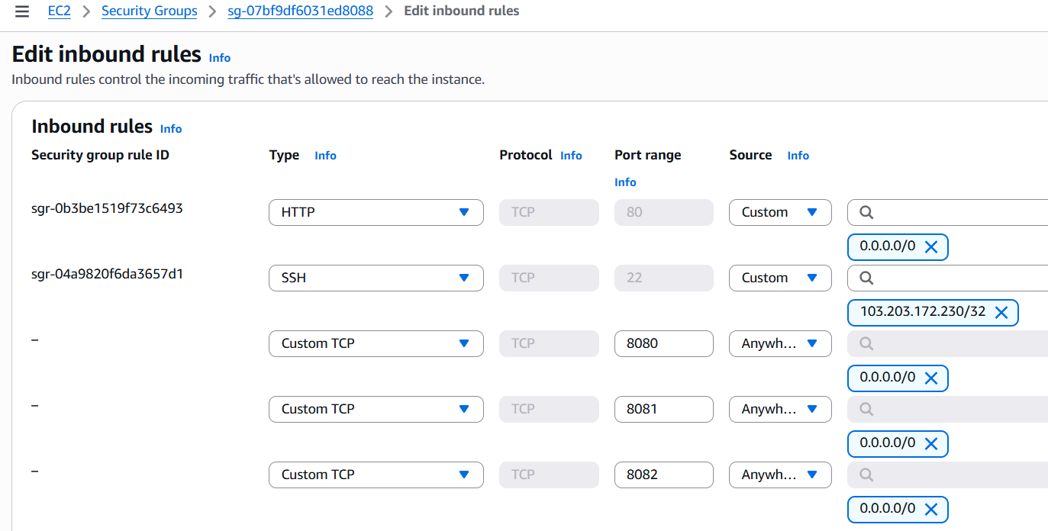
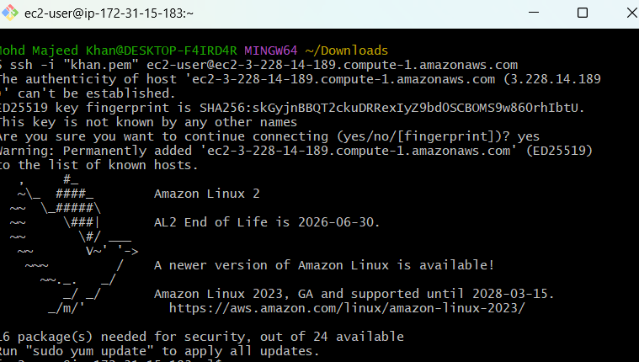
- Install Docker:
sudo yum update -y

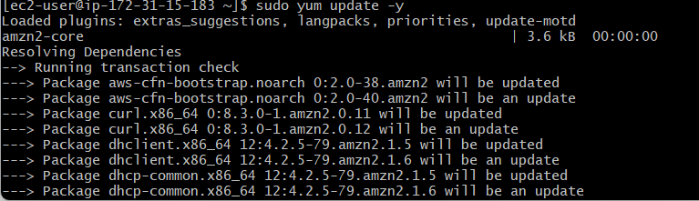
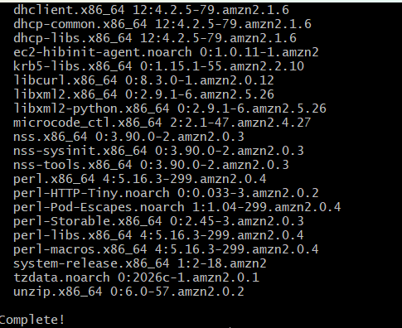
sudo amazon-linux-extras install docker -y
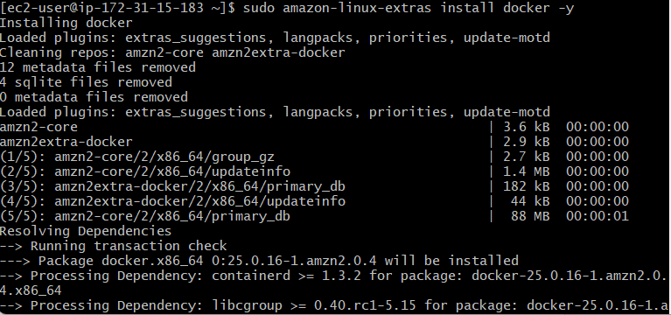
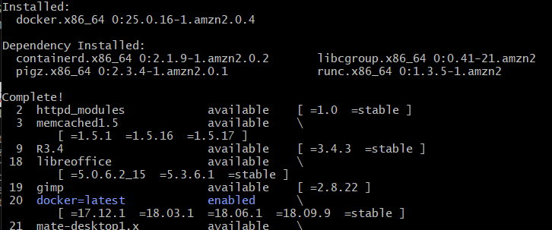
output confirms: Installed: docker.x86_64 0:25.0.16-1.amzn2.0.4

Start Docker: sudo systemctl start docker
Enable Docker: sudo systemctl enable docker
Check Docker: sudo systemctl status docker --no-pager
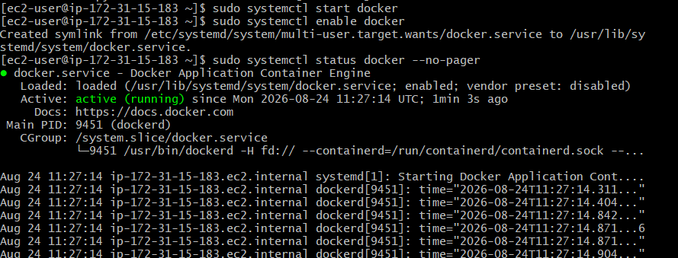
Test Docker: sudo docker –version
sudo docker run hello-world
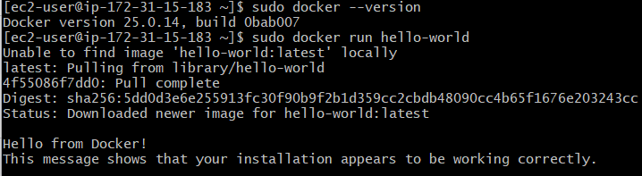
output confirms: Docker version 25.0.14

- Install Jenkins: let's check Java because Jenkins needs Java.
java -version
- we're on Amazon Linux 2, let's install Amazon Corretto 17, which is a good current Java version for Jenkins.
sudo rpm --import https://yum.corretto.aws/corretto.key
sudo curl -L -o /etc/yum.repos.d/corretto.repo https://yum.corretto.aws/corretto.repo
Then install Java 21: sudo yum install -y java-21-amazon-corretto-devel
java -version
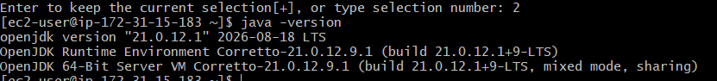
Next: Install Jenkins:
sudo wget -O /etc/yum.repos.d/jenkins.repo https://pkg.jenkins.io/redhat-stable/jenkins.repo
sudo rpm --import https://pkg.jenkins.io/redhat-stable/jenkins.io-2023.key
sudo yum install jenkins -y

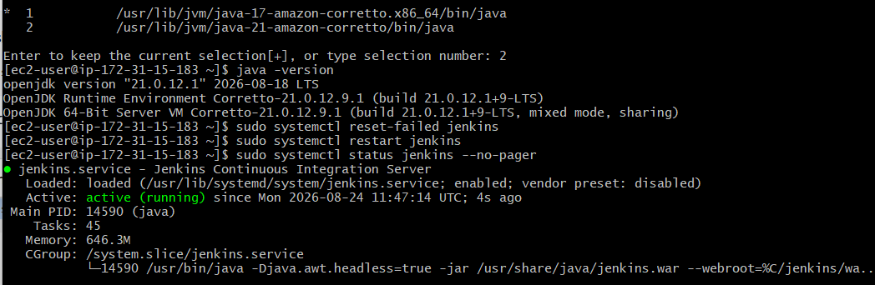
sudo cat /var/lib/jenkins/secrets/initialAdminPassword
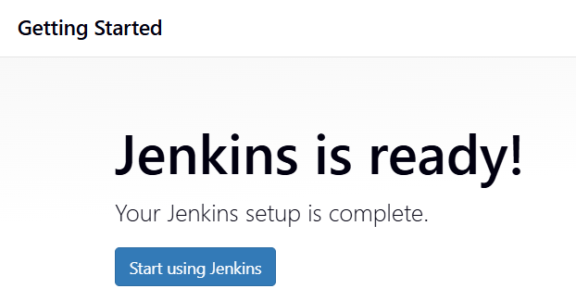

4: Install Apache
sudo yum install httpd -y
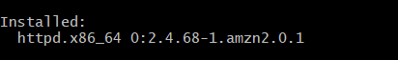

Change Apache from 80 → 8081:
sudo sed -i 's/^Listen 80$/Listen 8081/' /etc/httpd/conf/httpd.conf
grep '^Listen' /etc/httpd/conf/httpd.conf
Check Apache configuration:
sudo apachectl configtest output Syntax OK
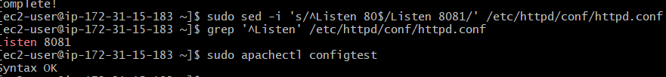Step 1 — Start Apache
sudo systemctl start httpd
sudo systemctl enable httpd
sudo systemctl status httpd --no-pager
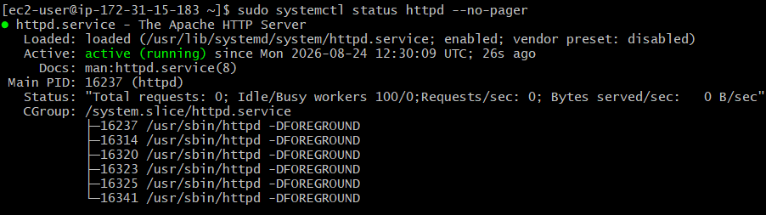
Test Apache locally: curl http://localhost:8081
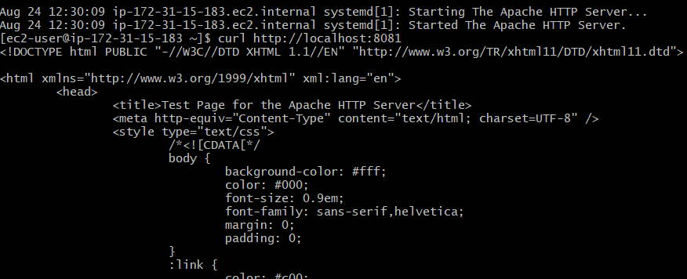
Apache is working correctly on port 8081. ✅

5: Install Nginx: Amazon Linux 2 has Nginx available through Amazon Linux Extras.

- sudo amazon-linux-extras install nginx1 -y
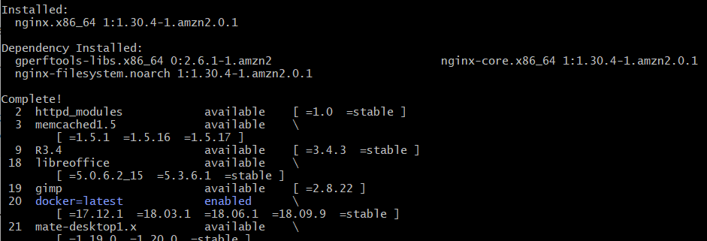
Now let's configure/check Nginx before starting it: sudo nginx -t
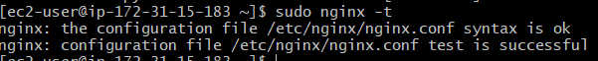
- Start Nginx
sudo systemctl start nginx
sudo systemctl enable nginx
sudo systemctl status nginx --no-pager
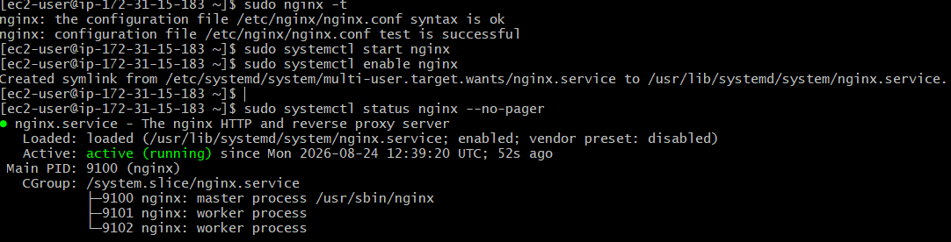
- Test Nginx
curl http://localhost
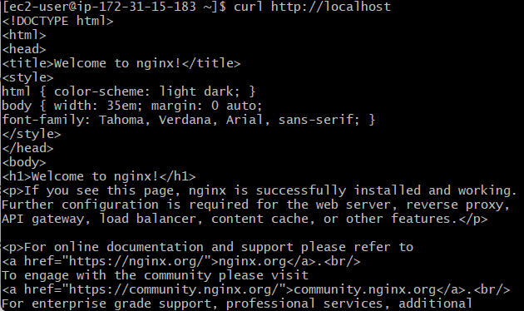
Nginx is working correctly on port 80. ✅

6: Install Apache Tomcat:
Check Tomcat in Amazon Linux Extras: amazon-linux-extras list | grep tomcat
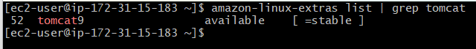
sudo amazon-linux-extras enable tomcat9
sudo yum clean metadata
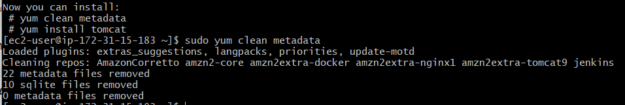
Install Tomcat:
sudo yum install tomcat -y
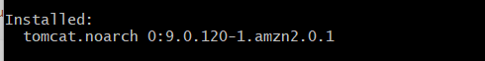
sudo systemctl start tomcat
sudo systemctl enable tomcat
sudo systemctl status tomcat
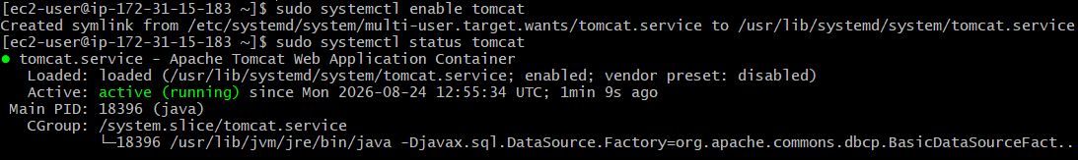

Change Tomcat port from 8080 to 8082
sudo vi /etc/tomcat/server.xml
port="8080" to port="8082"
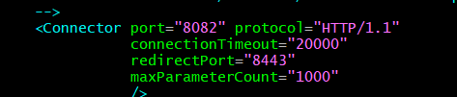
sudo systemctl status tomcat
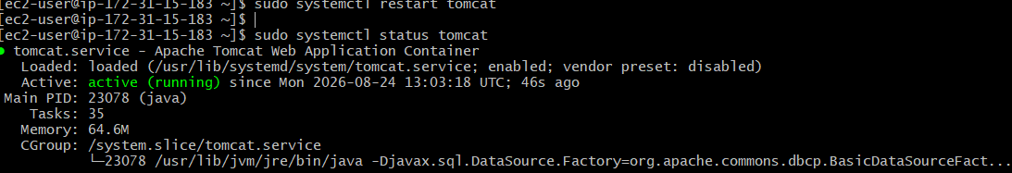
verify port 8082: sudo ss -lntp | grep 8082
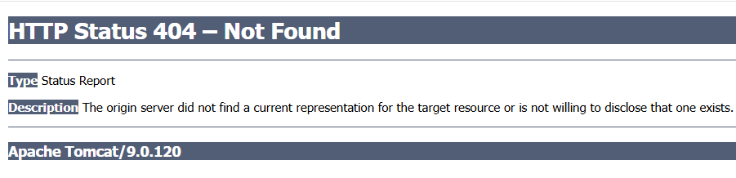
Install the Tomcat webapps: sudo yum install tomcat-webapps -y
ls -la /var/lib/tomcat/webapps/
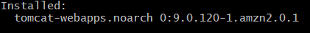
Restart Tomcat
sudo systemctl restart tomcat
sudo systemctl status tomcat
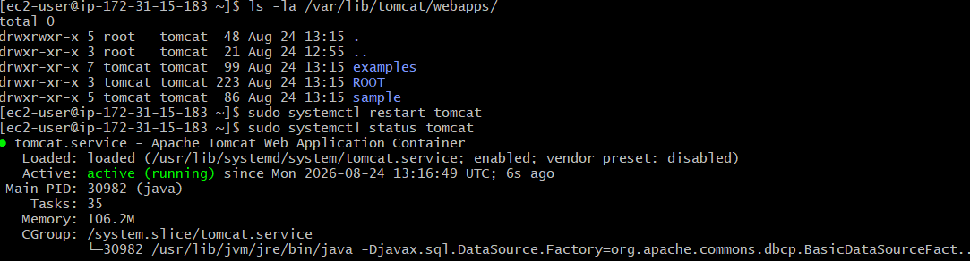

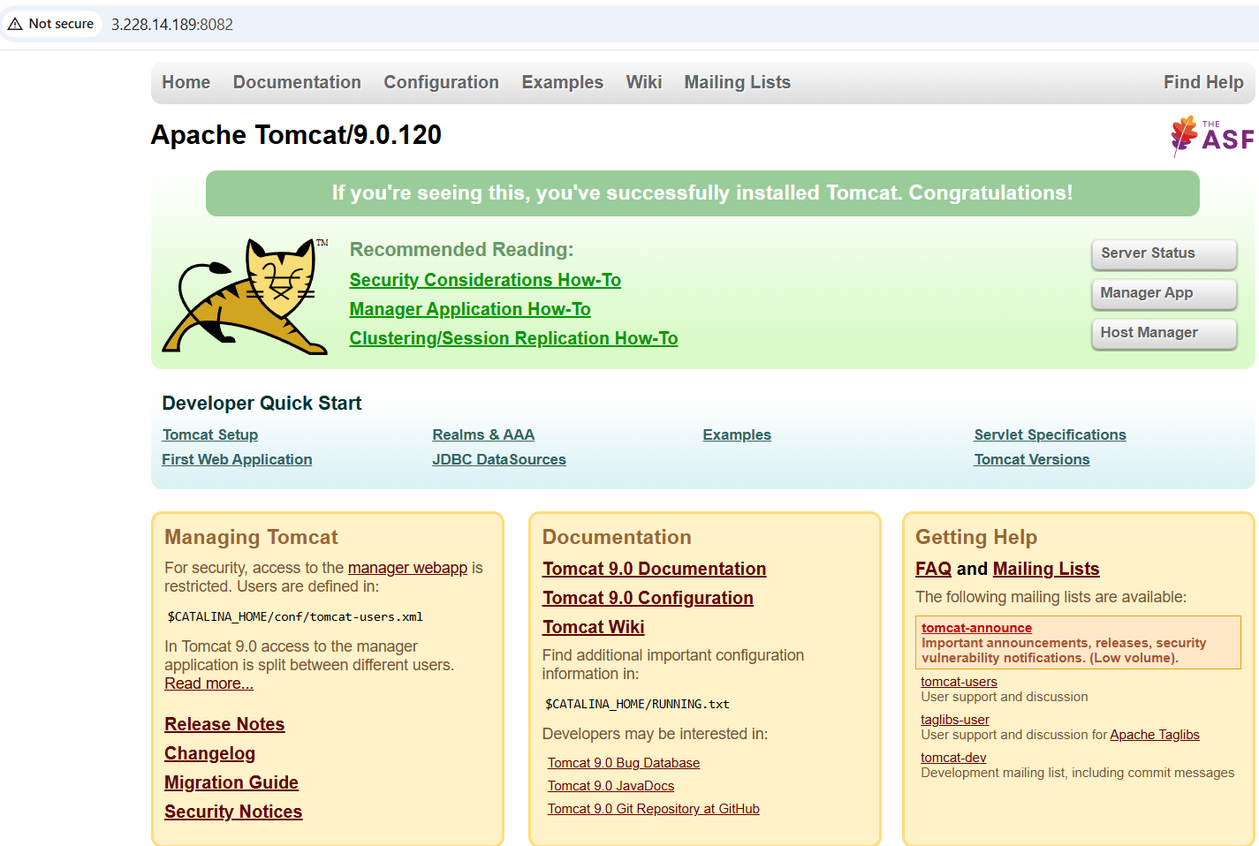
Final Result
- Tomcat 9.0.120 installed
- Tomcat service running
- Tomcat enabled at boot
- Port changed from 8080 → 8082
- AWS Security Group allows 8082/TCP
- Tomcat ROOT web application installed
- Tomcat welcome page successfully accessible at:
http://3.228.14.189:8082

